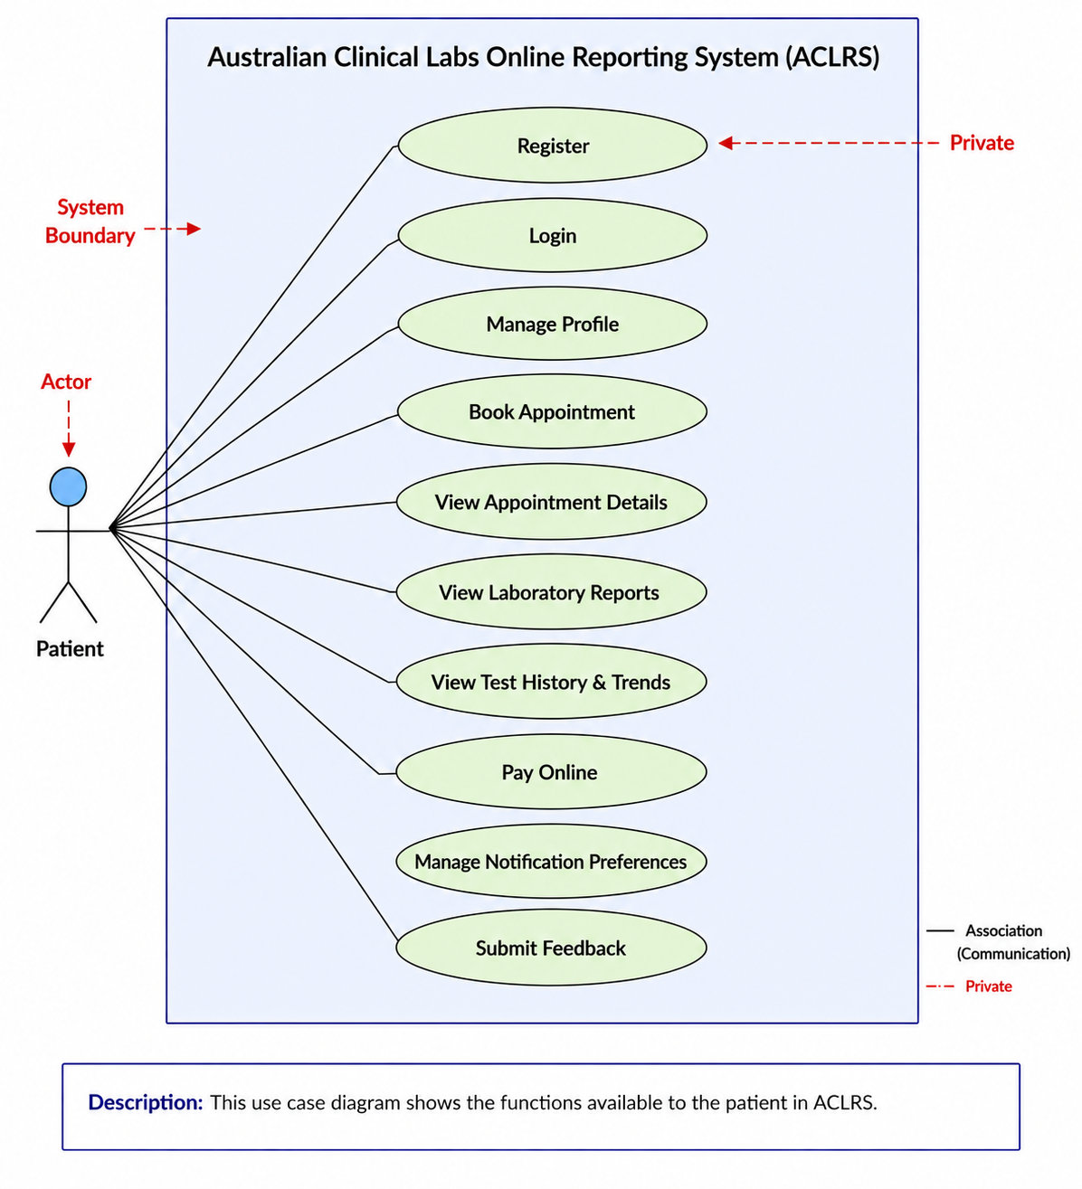
Figure: Use case diagram for patient

Patient Use Case Diagram – ACLRS
- This diagram shows how the Patient uses the Australian Clinical Labs Online Reporting System (ACLRS).
- The Patient is the main actor which is interacting with the system.
- The system boundary includes all the functions that are available in ACLRS.
- The patient can use these functions:
  - Register
  - Login
  - Manage Profile
  - Book Appointment
  - View Appointment Details
  - View Laboratory Reports
  - View Test History & Trends
  - Pay Online
  - Manage Notification Preferences
  - Submit Feedback
- The association lines show the connection between the patient and each system function.
- Overall, this diagram gives a simple view of all the main features that a patient can access in the ACLRS system.

